Numbers concepts

https://www.facebook.com/events/2091697584377505/

Q. 10101.... 94 digits is a 94 digit number. What will be the remainder obtained when this number is divided by 375?  
(a) 10

(b) 320

(c) 40

(d) None..

As we see here directly remainder nikalna is quite difficult so we will break 375 into 2 coprimes jinki divisibility apne ko pata ho.  
  
375= 125*3   
  
For 125=5^3 we check last 3 digits   
  
So last 3 digits of 1010....is 010  
  
So 10 mod 125= 10   
  
And for 3 its sum of digits   
  
So 1+0+1+0..  
= 47   
  
So 47 mod 3 = 2   
  
So now equate , Jo value common hogi that will be your answrr.  
  
125a+10 = 3b+2   
125a+8=3b  
Using hit n trial we find a value such that 125a+8 is a multiple of 3,   
a =2 satisfies  
  
So put a =2 in 125b+10, R = 260

Read how the divisibility of 125 is last 3 digits.

Hit like when done!!

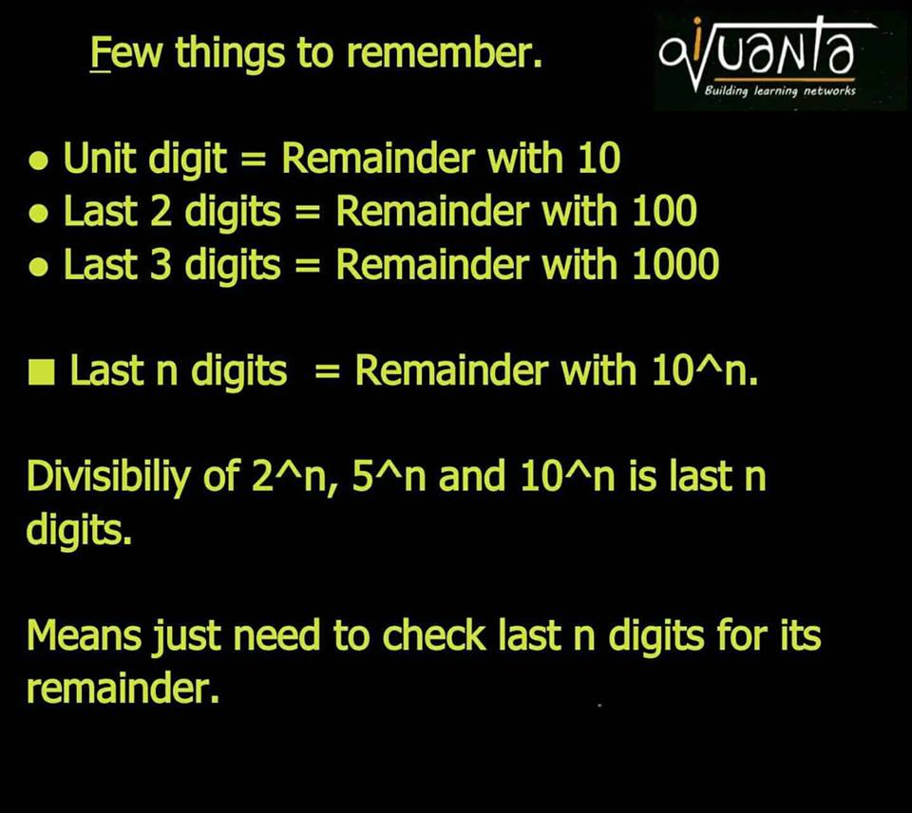

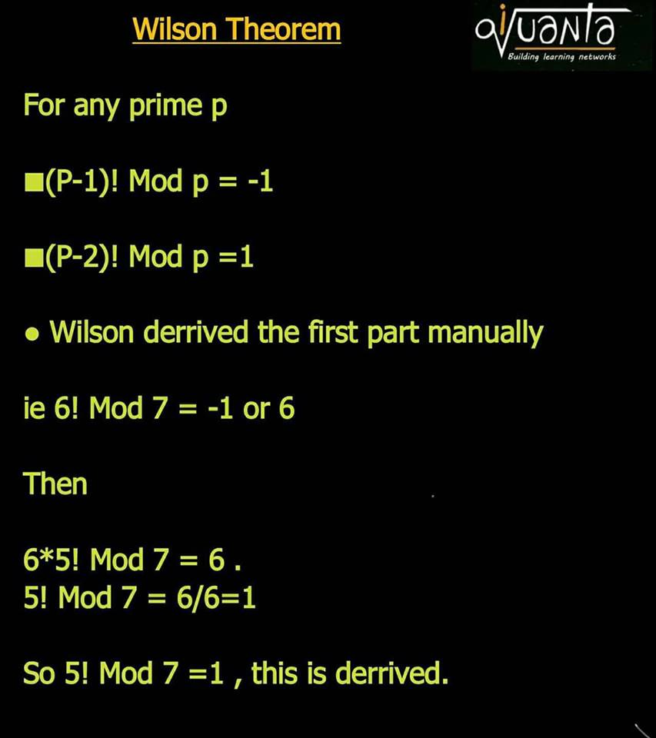



) -1 = 36   
2) 1   
  
explanation same as last post  
  
3) here, we know 35! Mod 37 = 1   
  
35*34! Mod 37 = -36   
  
-2*34! Mod 37 = -36 ( negative remainder concept as 1 = -36 and 35 = -2)   
  
So 34! Mod 36 = -36/-2 = 18



Follow these steps   
  
We know :  
45! Mod 47 = 1   
  
45*44! Mod 47 = 1 = - 46  
  
-2*44! Mod 47 = -46  
  
44! Mod 47 = -46/-2 = 23  
  
●General : (p-3)! Mod p = (p-1)/2, though I would suggest to not do by formula.



We know   
  
29! Mod 31 = 1   
  
29*28*27! Mod 31 = 1  
  
-3*-2*27! Mod 31 = -30  
  
6*27! Mod 31 = -30   
  
27! Mod 31 = -5 = 26  
  
( iska bhi generalise formula bna sakte hn but wont suggest as it might create confusion, t



Wilson is applicable only when divisor is prime p.   
  
But 1007 isn't .   
  
Hence remainder will be 0. As 1007=19*53 which gets cancelled when divided to 1004!=1*2*3....19...*59*...*1004  
  
■Remember:  
  
1001=13k  
1003=17k  
1007=19k  
  
1009 is the smallest 4 digit prime  
  
So Oa : 0



First Break 422 = 2*211   
  
209! Mod 2 = 0   
  
209! Mod 211= 1. (Wilson)   
  
So 2a = 211b+1   
  
b=1 satisfies to give R = 212  
  
A blend of crt and wilson. https://static.xx.fbcdn.net/images/emoji.php/v9/e40/1/16/LIKE.png(y)  
  
[#iQuanta](https://www.facebook.com/hashtag/iquanta?hc_location=ufi)

Lets move to euler

Q. 32^32^32 mod 7 = ?

oa : 4

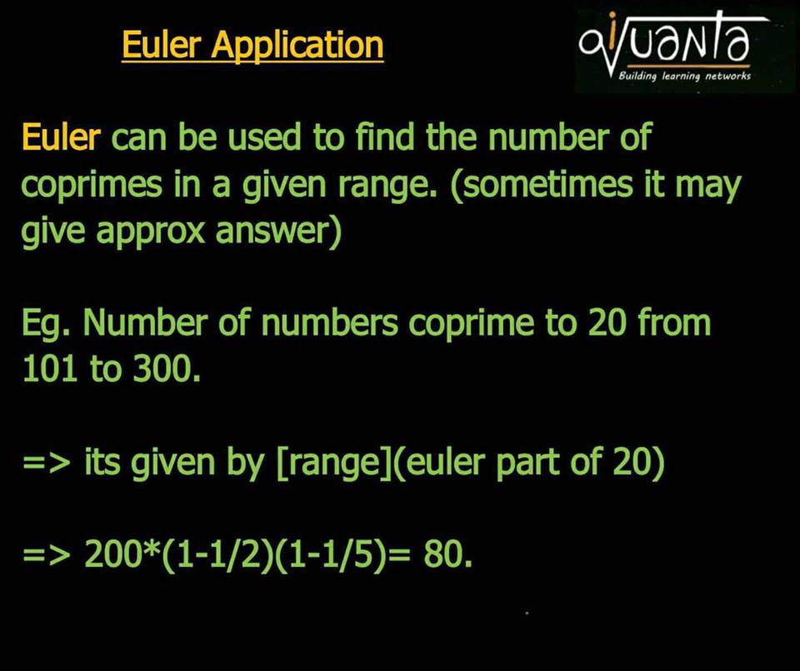

Q. How many coprimes of 42000 below 21000 ?

prime factors of 21000 = 2,3,5,7

so ans = 42000 * 1/2 * 2/3 * 4/5 * 6/7

 Range => 21000  
  
Euler part of 42000  
=> (1/2)(2/3)(4/5)(6/7)  
  
Coprime below 21000 =>   
  
21000 (1/2) (2/3) (4/5) (6/7) = 4800

Q. How many no. are in between 120<=n<=240 which are coprimes to 240 ?

Range = 122

122 * 1/2 * 2/3 * 4/5 = 32(approx)

240 = 2^4*3*5   
  
Range : 120  
  
(120)(1/2)(2/3)(4/5)  
  
= 32

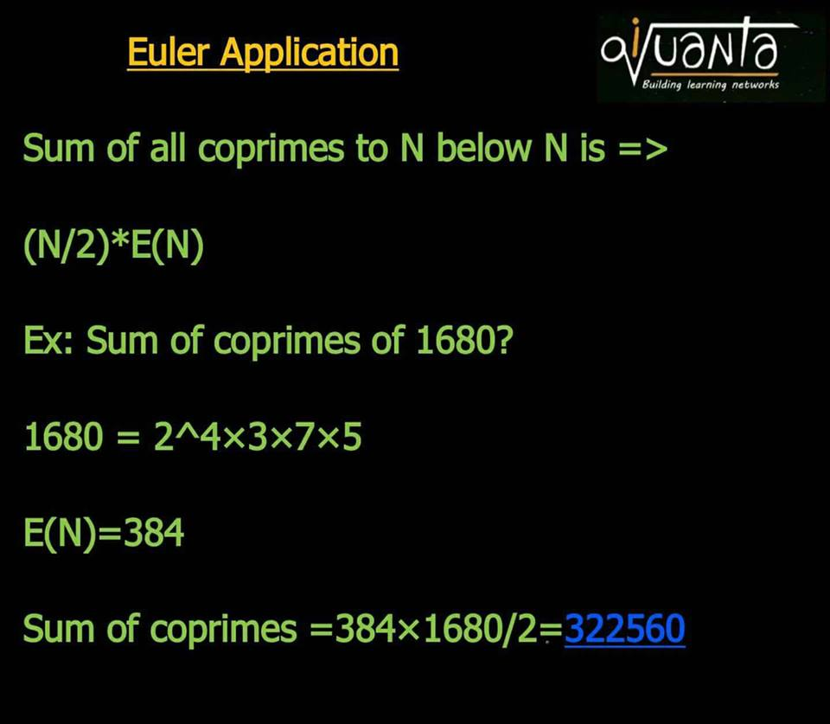

Sum of all coprimes to 200 below it is ?

200 * 1/2 * 4/5 * 100 = 8000

E(200)= (200/2)*(1/2)(4/5)= 80  
  
Ans : 100x 80=8000

1. Euler Applications & Problems

[**Indrajeet Singh**](http://iquanta.in/blog/author/administrator/)September 5, 2017



**245**

**SHARES**

[Share](https://www.facebook.com/sharer.php?u=http%3A%2F%2Fiquanta.in%2Fblog%2Feuler-application%2F)[Tweet](https://twitter.com/intent/tweet?text=Euler%20Applications%20%26%20Problems&url=http://iquanta.in/blog/euler-application/)

1. **Euler :**
2. **Pre requisites :  
   Co-prime definition :**Co-prime simply means when HCF of given numbers is 1, i.e, there is nothing common between them.  Eg: (1,2), (3,8), (9,19), (4,6,9) etc are co-prime groups.
3. **Meaning :** Euler of a Number,N means the number of co-primes to N below it.   
   Example : Euler of 10 = Number of co-primes to 10 , from 1 to 10. They are : 1,3,7,9 : 4. Hence the Euler of 10 is 4.
4. **Importance :** Euler is very important theorem to find Remainders, basically asked in CAT Mocks. Euler is special in a way that, it defines the cyclicity of a number.
5. **Formula :** Now what if the Euler of 100 or 1000, or a big number is asked, counting manually isn’t possible. Hence there is a direct formula to find Euler of any number N.
6. Let’s say N = a^x*b^y*c^z, where a,b,c are primes.   
   **E(N) = N[(1-1/a)(1-1/b)(1-1/c)]**  
   Example : Euler of 100, (100=2^2*5^2) : E(100) = 100(1-1/2)(1-1/5) = 100(1/2)(4/5) = 40.   
   It simply means there are 40 co-prime numbers to 100, below 100.
7. **For a prime number P, as p is the only prime so, E(P) = P(1-1/P) = P-1 always.**
8. **Application : 1)**  Ps : Mod just means remainder.  So 6 mod 4 =2 or  12 mod 4=0. 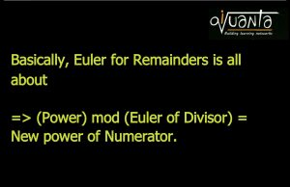
9. 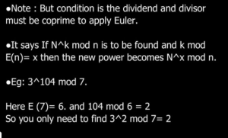
10. **Application: 2)**
11. 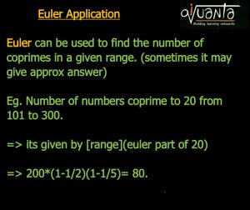
12. **Application: 3)**
13. 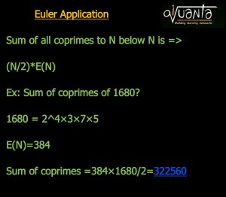
14. **Practice Conceptual Questions Now:**

**(To know it’s answers and solutions, post in**[**iQuanta Facebook group**](https://www.facebook.com/groups/Rockthecat) **Tip: All concepts may or may not be applicable, unlike other materials. Play smart, like an entrepreneur.**

1. 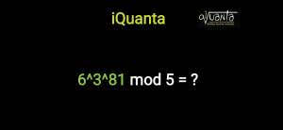
2. 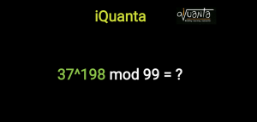
3. 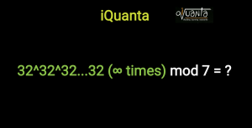
4. 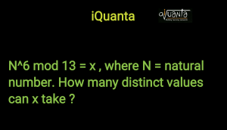
5. 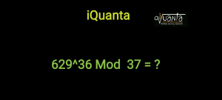
6. 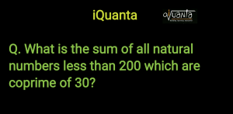
7. 
8. 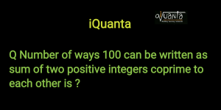
9. 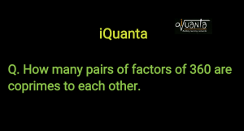
10. 
11. 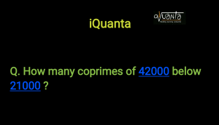

1 , 37 , 4 , 2 , 1 , 400 , , 20 , , 9600 , 4800.